Detailed Game Specification:
TRON-lightcycle
Course: COMP 2659, Winter 2017
Instructor: Paul Pospisil
Author(s): Jaden McConkey
Last Modified: Jan 9th 2017

1. General Game Overview
Tron – light cycle is a 2D territory claiming skill based racing game. The aim is to survive longest within the confines of the playing field while also interfering with the survival/play of the competing player.
Play is controlled via the WASD keys or the arrow keys (user preference) each player directly controls a “lightcycle” that can move up,down,left and right within the rectangular playing field. For both players any movement is trailed by a “light wall” with collision, if either player comes into contact with either the field wall, their own light wall or the opposing players light wall, they have died and the opposing player win.
Gameplay is primarily two player, however there will also be a single person timed training mode to allow for practice in this highly skill based game.

Example Gameplay Screen(sample taken from the Tron arcade Game ) (will be greyscale)
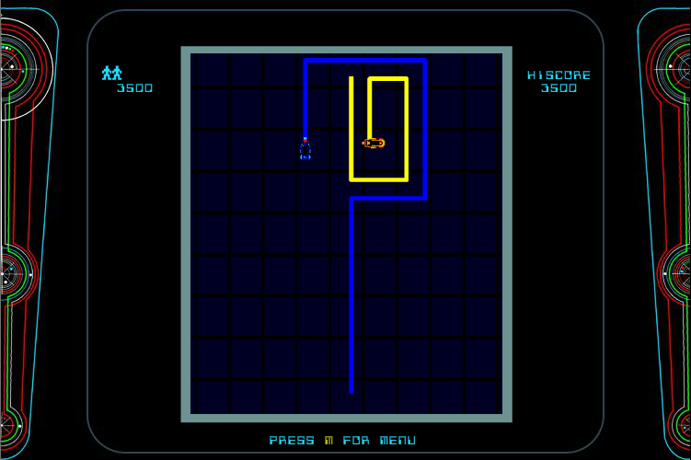
[First sample screenshot goes here. Remember to properly cite all images obtained from other sources.]

2. Game Play Details for Core 1-Player Version
[Second sample screenshot goes somewhere in section 2. Include additional screen shots and diagrams throughout section 2 as necessary.]

Objectives and Rules
[Description of game start state goes here.]
[Description of game rules goes here. Include scoring/winning/losing conditions as applicable.]

Objects
Object or Object Type Name | Properties | Behaviours | Graphical Image
[E.g. ship] | - [E.g. position (integer pair)]  - [E.g. speed (integer)  - ? | - [E.g. teleport] | [Small image.]

[Note: for some games, it may not be appropriate or realistic to include images for all object types. However, this is recommended if possible. Simple bitmap-style images (e.g. 8×8, 4×4, 16×16, etc.) are best for many game types. There are free tools to help you construct such images.]
[Note: for some games a particular object may have >1 associated image, depending on its current state (e.g. Mario walking left vs. Mario walking right).]

Physics
[Description of game world’s physical laws goes here if applicable, e.g. regarding gravity, object velocity/acceleration/momentum, collision detection, rebounding, etc.]

Asynchronous (Input) Events
[Note: keyboard input is required of all games. Additional mouse input is optional for core game play.]
Event Name | Triggering Input Event | Description
[E.g. “teleport request”] | [E.g. ‘T’ key is depressed] | […]  [Note: the description should include a summary of the effect on the relevant objects and their properties.]

Synchronous (Timed) Events
[Note: on the Atari ST, one easy option will be to make use of a 70 Hz timer (i.e. 70 ticks per second). So, it may be easiest to base timed events on multiples of 1/70th of a second.]
[Note: the trigger for a synchronous event is typically based on a clock. But, some synchronous events are also triggered by the occurrence of other synchronous events. E.g. a ship may move forward 1 pixel every 1/10th of a second, but it might as a result collide with an obstacle – these are two distinct events, one triggered directly by clock ticks and the other conditionally triggered by the original movement.]
Event Name | Trigger Timing | Description
[E.g. ship moves] | [E.g. every 1/10th of a second.] | [E.g. ship moves forward speed pixels (where speed is a property of the ship object)]

Condition-Based (Cascaded) Events
[Note: some events may trigger other events, conditionally. This is called event “cascading”. The triggering event(s) may themselves be asynchronous, synchronous, or other condition-based events.]
Event Name | Triggering Condition | Description
[E.g. ship collides] | [E.g. ship has moved and ship bounding box intersects with obstacle bounding box] | […]

Hypothetical Gaming Session
[Narration of typical example session goes here.]

3. Game Play Details for Core 2-Player Version
[A detailed description of the core 2-player version goes here. Include a description of all differences between this and the core 1-player version (e.g. rule and game-play modifications, differences in graphics, etc.]
[2-player sample screenshot goes here.]

4. Sound Effects
Sound Effect Name | Brief Description | Event which Triggers Playback
[E.g. ship explosion] | [E.g. white noise with a fast attack and slow decay] | [E.g. ship collides]

[Optional: brief description of background music. Music will be required by assignment 3.]

5. Additional Features (Time Permitting)
-Fixed ai patterns to battle against with a total of 12 stages with increasing dificulty
-mode for playing on the same keyboard

